|  |
| --- |
| Sonoran Sleep Center, AZ  **e-Care Systems** |

**Table of Contents**

**EXECUTIVE SUMMARY ............................................................................................................................................................... 4**

**SYSTEM PLANNING PHASE REPORT ..................................................................................................................................... 4**

1.0 INTRODUCTION .............................................................................................................................................................................................4 2.0 PROJECT JUSTIFICATION ..............................................................................................................................................................................4 3.0 CLIENT AND INDUSTRY BACKGROUND .....................................................................................................................................................5 4.0 PROJECT SCOPE .............................................................................................................................................................................................6 5.0 PROJECT METHODOLOGY ............................................................................................................................................................................6 6.0 PROJECT PLAN ..............................................................................................................................................................................................6

**SYSTEM ANALYSIS PHASE REPORT ...................................................................................................................................... 8**

# 7.0 REQUIREMENTS ............................................................................................................................................................................................8

*7.1 Fact Finding .......................................................................................................................................................................................... 8*

*7.2 Business requirements...................................................................................................................................................................... 8*

*7.3 User requirements .............................................................................................................................................................................. 8*

*7.4 Functional requirements ................................................................................................................................................................. 9*

*7.5 Non-Functional requirements ....................................................................................................................................................... 9*

# 8.0 DATA MODEL – CONTEXT DIAGRAM ..................................................................................................................................................... 10 9.0 DATA MODEL – LEVEL 0 DIAGRAM ....................................................................................................................................................... 10 10.0 SWIMLANE DIAGRAMS ........................................................................................................................................................................... 11

*10.1 Patient Registration and Insurance Eligibility Process ................................................................................................ 11*

*10.2 Patient Billing Processing Flow .............................................................................................................................................. 12*

**SYSTEM DESIGN PHASE REPORT ........................................................................................................................................ 13**

11.0 PHYSICAL ER DIAGRAM ........................................................................................................................................................................ 13

*11.1 Entities ............................................................................................................................................................................................... 13*

# 12.0 STRUCTURE CHART ................................................................................................................................................................................ 14 13.0 ARCHITECTURE ....................................................................................................................................................................................... 15 14.0 USER INTERFACE .................................................................................................................................................................................... 17

*14.1 Sign Up Page ................................................................................................................................................................................... 17*

*14.2 Login Page ....................................................................................................................................................................................... 18* *14.3 Dashboard ........................................................................................................................................................................................ 19*

*14.4 Add Patient Details....................................................................................................................................................................... 19*

*14.5 Patient Records .............................................................................................................................................................................. 22*

*14.6 Patient Summary .......................................................................................................................................................................... 23*

*14.7 Edit Patient Data .......................................................................................................................................................................... 24*

*14.8 Profile ................................................................................................................................................................................................. 25*

*14.9 InTakeQ <> e-Care Interaction Journey .............................................................................................................................. 26*

*14.10 WayStar <> e-Care Interaction Journey ........................................................................................................................... 27*

# 15.0 TESTING PLAN ......................................................................................................................................................................................... 27

*15.1 Unit Testing ..................................................................................................................................................................................... 27*

*15.2 Stress Testing .................................................................................................................................................................................. 28*

*15.3 Integration Testing ...................................................................................................................................................................... 29*

*15.4 Systems Testing ............................................................................................................................................................................. 30*

*15.5 Acceptance Testing ...................................................................................................................................................................... 32*

# 16.0 IMPLEMENTATION PLAN ....................................................................................................................................................................... 33

*16.1 Objectives ......................................................................................................................................................................................... 33*

*16.2 Details and Deliverables ............................................................................................................................................................ 33*

*16.3 Implementation Plan Schedule ............................................................................................................................................... 36*

17. CONCLUSION ............................................................................................................................................................................................... 39

# **Executive Summary**

The Sonoran Sleep Center is facing billing inefficiencies that are causing delays in payment processing and creating more manual work for staff, resulting in lost revenue opportunities. To address these issues, we recommend implementing an API integration between WayStar and InTakeQ.

These improvements are expected to streamline processes, reduce manual labor, increase accuracy in payment processing and record-keeping, and improve revenue cycle management. Implementing these improvements will help the Sonoran Sleep Center to increase revenue opportunities, improve staff productivity, and streamline its revenue cycle.

By automating the payment posting process the center can reduce processing time and manual labor, leading to improved financial performance. The project is expected to take nearly 135 days to complete.

# **System Planning Phase Report**

## 1.0 Introduction

In today's fast-paced business world, efficient billing systems are essential for managing finances and maintaining customer satisfaction. However, the process of generating and managing invoices can be time-consuming and prone to errors. This is where technology comes in.

By leveraging the power of automation and digital tools, businesses can streamline their billing process, reduce errors, and improve overall efficiency. In this context, our project aims to develop a modern and user-friendly billing software that can simplify the billing process for our client, Sonoran Sleep Center.

This software will not only help save time and money but will also improve the accuracy and transparency of their billing operation, make the insurance claim processing and payments more faster, by implementing auto-fill application system to automate processes and reduce manual labor.

## 2.0 Project Justification

The current billing system used by Sonoran Sleep Center is inefficient and prone to errors, causing delays in payment processing and creating manual work for staff. These inefficiencies are resulting in lost revenue opportunities, impacting the financial performance of the center. By developing a modern and user-friendly billing software, our project aims to automate and streamline the billing process for Sonoran Sleep Center, reducing errors, saving time, and increasing transparency.

The implementation of an API integration between WayStar and InTakeQ, will further improve the accuracy and efficiency of the billing operation. The automation of payment posting, electronic record-keeping will reduce manual labor, increase accuracy in payment processing and recordkeeping, and improve revenue cycle management. These improvements will help Sonoran Sleep Center increase revenue opportunities, improve staff productivity, and streamline its revenue cycle.

Overall, this project will address the inefficiencies in the current billing system and improve financial performance for Sonoran Sleep Center. By leveraging the power of automation and digital tools, we aim to create a billing system that is efficient, accurate, and transparent, providing a positive impact on the center's bottom line.

## 3.0 Client and Industry Background

Sonoran Sleep Center is a comprehensive sleep medicine clinic and laboratory that specializes in diagnosing and treating various sleep-related conditions, such as insomnia, narcolepsy, restless leg syndrome, circadian rhythm disorder, and parasomnias. The practice is physician-owned and operated and is located in the Phoenix metro area.

The team at Sonoran Sleep Center is led by Dr. Patel, who has extensive experience in sleep medicine and is dedicated to improving the quality of life for individuals suffering from sleep disorders. Dr. Patel takes a patient-centered approach to care and works with each patient to develop a personalized treatment plan that addresses their specific needs and concerns.

One of the unique features of Sonoran Sleep Center is its inviting and comfortable overnight study suites, which are designed to look more like hotel rooms than medical offices. Patients are able to undergo sleep studies on-site, which allows for more accurate diagnosis and treatment of sleep disorders.

Sonoran Sleep Center is committed to providing evidence-based, comprehensive patient care to optimize sleep health. The practice utilizes the latest technologies and research in the field of sleep medicine to provide the best possible care to its patients.

## 4.0 Project Scope

The scope of this project is to develop a modern and user-friendly software for the Sonoran Sleep Center that simplifies the billing process, improves the accuracy and transparency of their billing operation, and streamlines the revenue cycle. The project includes the following specific objectives:

* Implement a software solution that autofills data onto WayStar and InTakeQ to streamline the payment posting process and eliminate manual data entry errors.
* Develop a user-friendly interface for the software to simplify the billing process for the Sonoran Sleep Center.
* Test and debug the software to ensure accuracy and efficiency in the billing process.
* Train Sonoran Sleep Center staff on the use of the new software and referral management system.

## 5.0 Project Methodology

For the Sonoran Sleep Center billing system project, we will be using the Agile methodology. Agile methodology is being used for this project because it is a flexible and iterative approach to project management that allows for continuous feedback and adaptation throughout the project lifecycle.

With the Agile methodology, the development team can work in small increments, constantly testing and improving the software, which aligns well with the project's goal of creating a modern and user-friendly billing software. Additionally, Agile methodology emphasizes customer collaboration, ensuring that the project meets the customer's needs and requirements.

## 6.0 Project Plan

|  |  |  |  |  |
| --- | --- | --- | --- | --- |
| **WBS** | **Name** | **Duration (days)** | **Start** | **Finish** |
| **1** | **Billing Information Automation Tool** | **135** | **05 April 2023** | **18 August 2023** |
| **1.1** | **Planning** | **15** | **05 April 2023** | **20 April 2023** |
| 1.1.1 | Plan Project Initiation Meeting | 5 | 05 April 2023 | 10 April 2023 |
| 1.1.2 | Communications Plan | 5 | 12 April 2023 | 17 April 2023 |
| 1.1.3 | Establish Project Steering Committee | 5 | 12 April 2023 | 17 April 2023 |
| 1.1.4 | Identify Stakeholders | 3 | 12 April 2023 | 15 April 2023 |
| 1.1.5 | Charter Approval | 5 | 15 April 2023 | 20 April 2023 |

### 1.2 Analysis 41 21 April 2023 01 June 2023

1.2.1 Establish Requirements 14 05 April 2023 19 April 2023

1.2.1.1 Staff Requirements 7 12 April 2023 19 April 2023

HIPAA Compliance

1.2.1.2 7 12 April 2023 19 April 2023

Requirements

Layout and Front End

1.2.1.3 10 12 April 2023 22 April 2023 reuirements

1.2.2 Develop Use Cases 10 19 April 2023 29 April 2023

1.2.3 Review Use Cases 7 20 April 2023 27 April 2023

1.2.4 Approve Use Cases 5 27 May 2023 01 June 2023

### 1.3 Design 35 02 June 2023 07 July 2023

1.3.1 High Level Design Document 14 02 June 2023 16 June 2023

1.3.2 Design Review 7 02 June 2023 09 June 2023

1.3.3 Tool Design 21 09 June 2023 30 June 2023

1.3.3.1 Develop Front-End Design 14 17 June 2023 01 July 2023

1.3.3.2 Develop Back-End Design 14 23 June 2023 07 July 2023

### 1.4 Testing 21 07 July 2023 28 July 2023

Reuirement Accomplishment

1.4.1 7 07 July 2023 14 July 2023 analysis

1.4.2 Unit Testing 7 08 July 2023 15 July 2023

1.4.3 Test Use Cases 6 15 July 2023 21 July 2023

1.4.4 Sign-Off on Testing 7 21 July 2023 28 July 2023

### 1.5 Implementation 21 28 July 2023 18 August 2023

1.5.1 Training 14 29 July 2023 12 August 2023

1.5.1.1 Staff Training 7 30 July 2023 06 August 2023

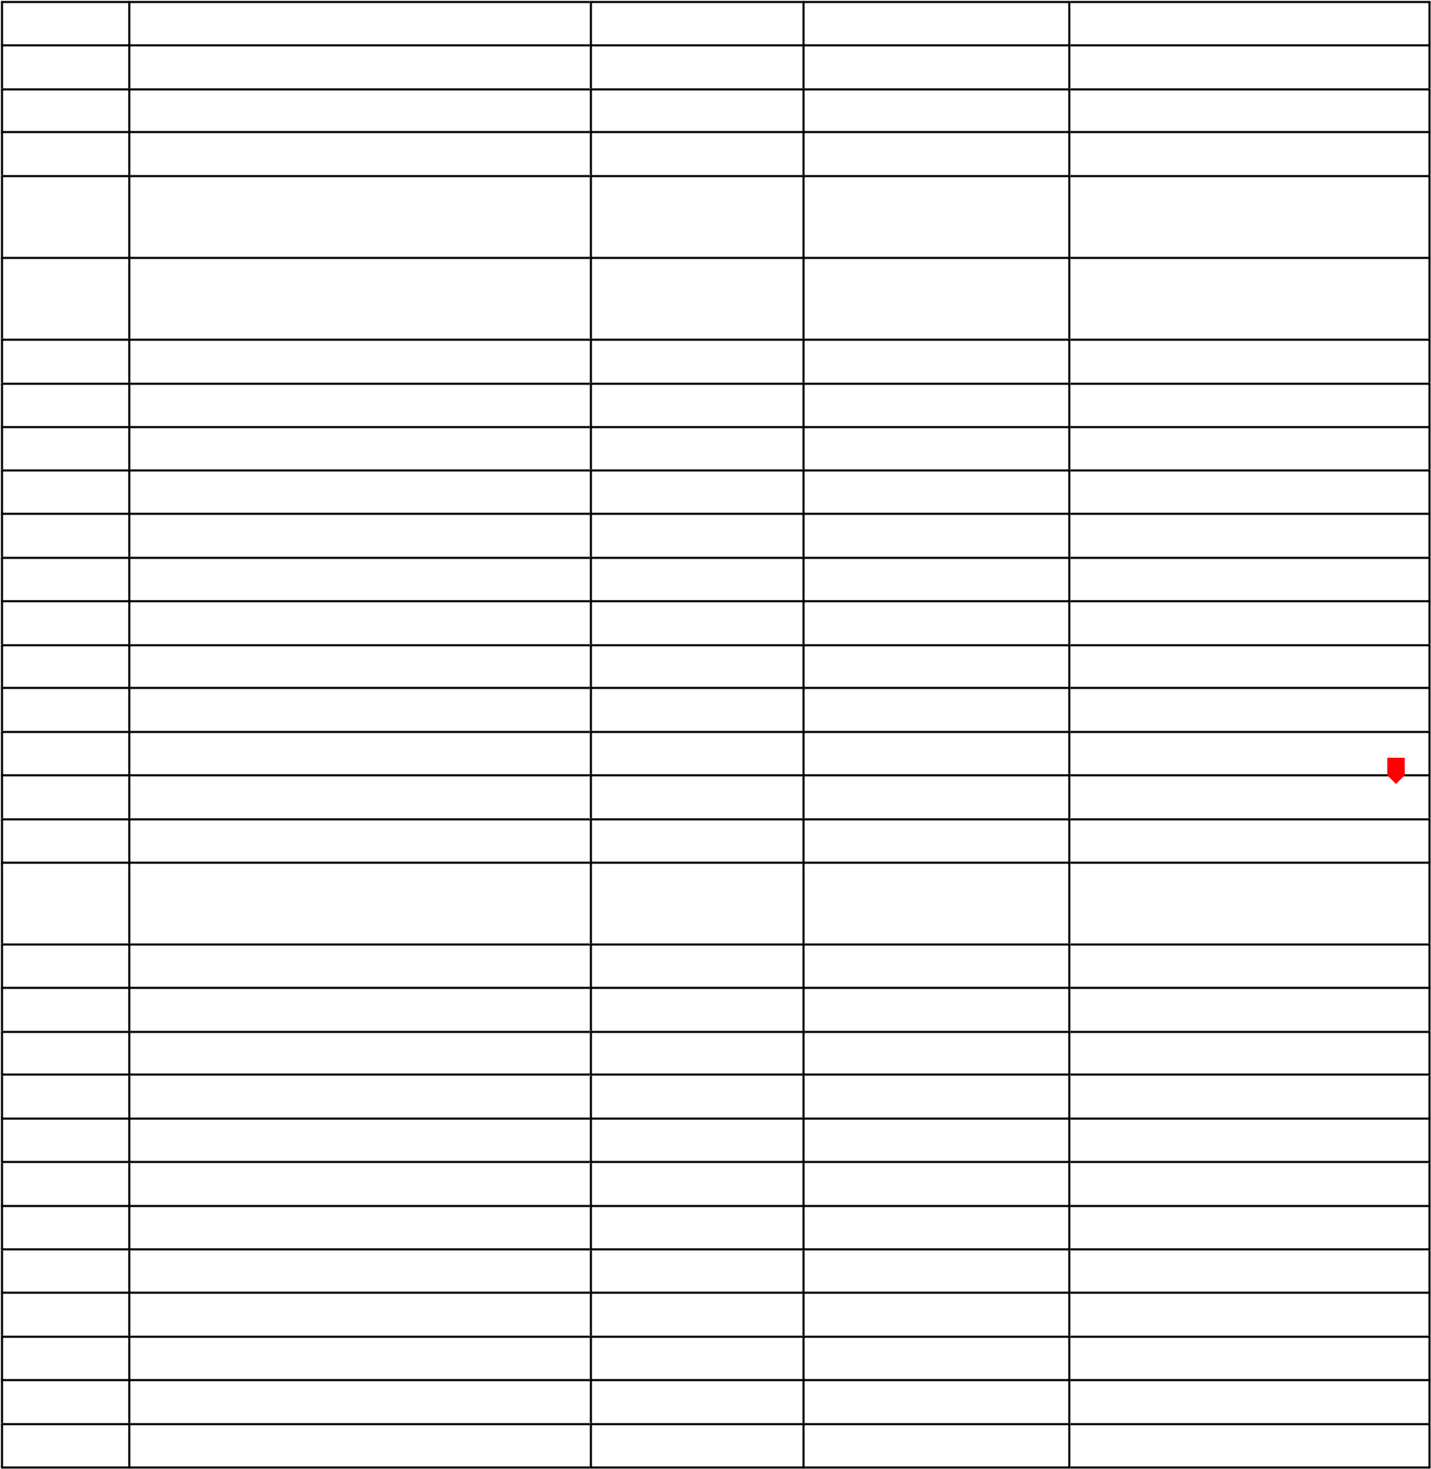1.5.2 Deployment 4 30 July 2023 03 August 2023 1.5.3 Maintenance 19 30 July 2023 18 August 2023

1.5.4 Operations 19 30 July 2023 18 August 2023

1.5.5 Track Performance 19 30 July 2023 18 August 2023

1.5.6 Feedback Analysis 19 30 July 2023 18 August 2023

# **System Analysis Phase Report**

## 7.0 Requirements

### 7.1 Fact Finding

During the fact-findin g phase, our team conducted extensive research to gather information on the current state of the client's system. We began by conducting an in-depth interview with the client to gather information on their current processes, challenges, and pain points.

Based on the information gathered from the interview, we documented the client's system status, including their current capabilities, limitations, and areas that require improvement. By deep diving and talking to the larger team we could collect, and analyse their existing state of data and map it with other similar players in the industry.

This helped us bring best industry practices to the table for our client.

Overall, the fact-finding phase provided valuable insights into the client's system status, user requirements, and potential areas for improvement.

### 7.2 Business requirements

* The Billing Information Autofill tool should increase the productivity and efficiency of the hospital staff.
* The Billing Information Autofill tool should reduce data entry errors and improve data accuracy.
* The Billing Information Autofill tool should be cost-effective and provide value for money.
* The Billing Information Autofill tool should integrate seamlessly with existing software Waystar and InTakeQ.

### 7.3 User requirements

* The Billing Information Autofill tool should be customizable to the staff's needs as it should be able to auto-populate patient data to Waystar and eligible patient information into InTakeQ.
* The ability to save/edit the patient information in the database from which the Billing Information Autofill tool retrieves information should be granted to staff.
* The Billing Information Autofill tool should save time and reduce manual data entry.
* The Billing Information Autofill tool should be secure and protect sensitive patient data.
* The Billing Information Autofill tool should suggest possible field entries on Waystar and InTakeQ software with a couple of letters of the patient name typed in.

### 7.4 Functional requirements

* The Billing Information Autofill tool should provide staff with the option to manually enter or override data in Waystar or InTakeQ form fields. This means that, if necessary, staff can input information such as patient data, Billing data(credit details), and appointment data, instead of relying solely on the autofill function.
* The Billing Information Autofill tool should automatically fill form fields on Waystar and IntakeQ with appropriate data like insurance information and patient data.
* The Billing Information Autofill tool should support multiple data types, such as text, numbers, dates, and addresses.
* The Billing Information Autofill tool should provide accurate suggestions and predictions for data entry.
* The Billing Information Autofill tool should validate data entered in Waystar and InTakeQ.

### 7.5 Non-Functional requirements

* The Billing Information Autofill tool should be secure and protect patient data from unauthorized access.
* The Billing Information Autofill tool should be reliable and perform consistently without downtime or errors.
* The Billing Information Autofilltool should perform efficiently and quickly, with minimal delay or lag when filling fields on both software.
* The Billing Information Autofill tool should be user-friendly, with clear instructions and labels.
* The Billing Information Autofill tool should be compatible with a variety of browsers and operating systems.

## 8.0 Data Model – Context Diagram

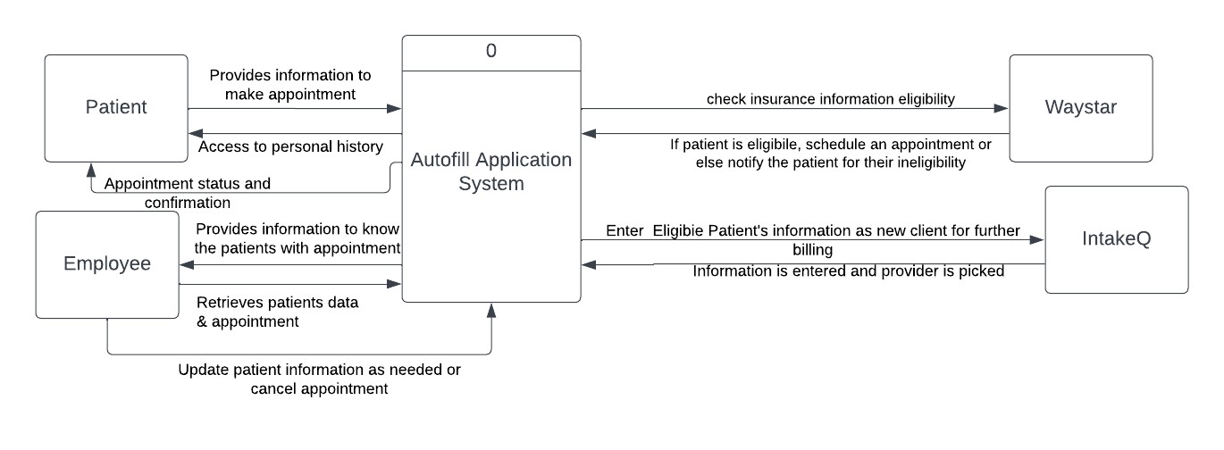

## 9.0 Data Model – Level 0 Diagram

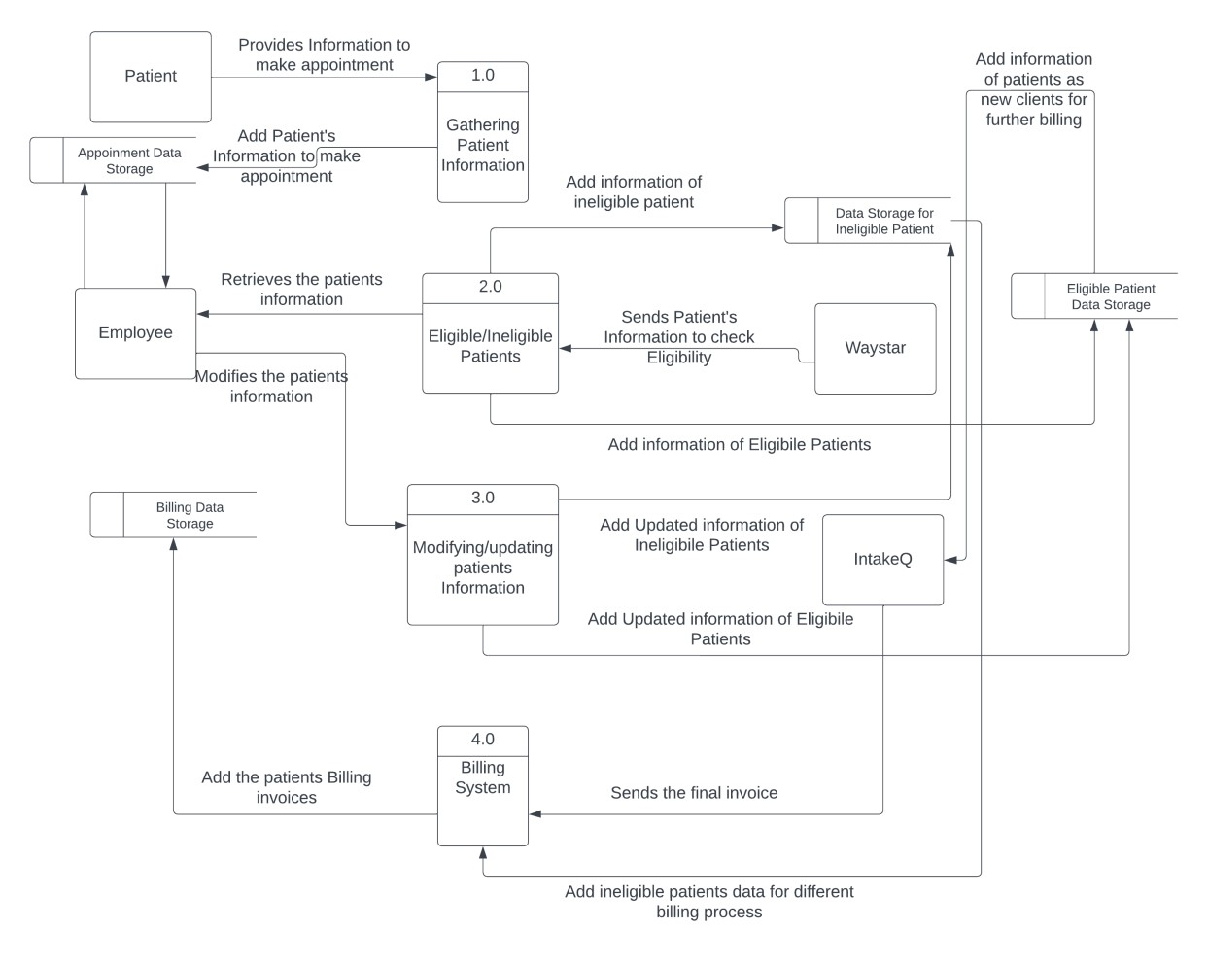

***External Entities:***

 **Patients:** Patients of Sonoran Sleep Center are individuals of all ages who suffer from various sleep-related disorders. They seek care at Sonoran Sleep Center to improve their sleep quality and overall health.

 **Employees:** The Sonoran Sleep Center team consists of healthcare professionals, including sleep technologists, nurses, medical assistants, and administrative staff. They collaborate to provide excellent care to patients and pursue ongoing professional development to stay up-to-date with advances in sleep medicine.

## 10.0 Swimlane Diagrams

### 10.1 Patient Registration and Insurance Eligibility Process

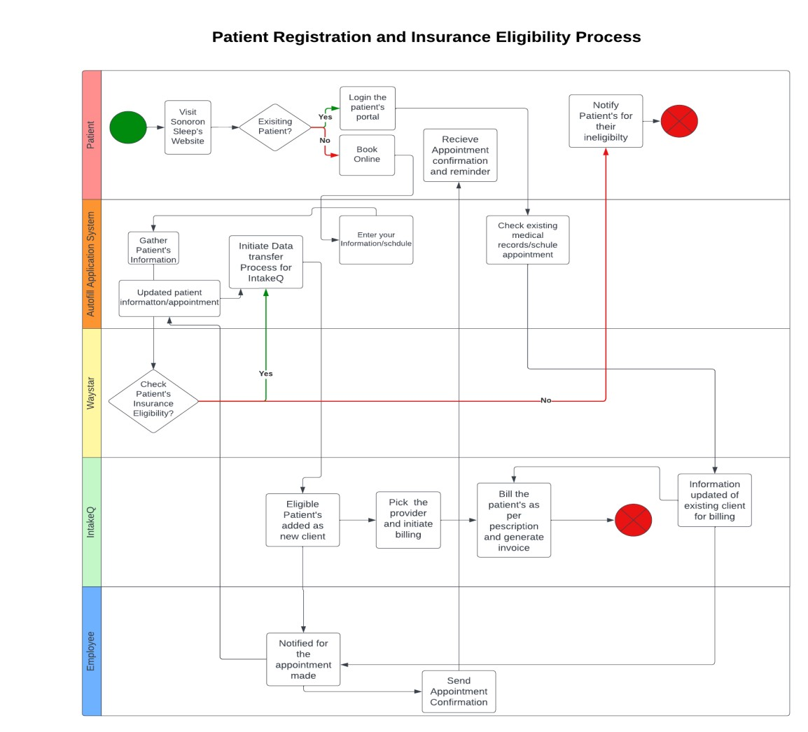

**Description:** The swimlane process flow diagram illustrates how patients, whether new or existing, use the healthcare portal website to schedule an appointment based on the available times. The eligibility of the patient's health insurance is checked by the Waystar software before the appointment confirmation is issued. The Autofill Application system assists in replicating the required data to IntakeQ as necessary. This process involves several entities, including patients, the Employee Team, Waystar software, IntakeQ, and the Autofill Application System.

### 10.2 Patient Billing Processing Flow

**Description:** The swimlane diagram illustrates the billing processing mechanism in this system. The employee team initiates the process by reviewing the services provided to the patient and preparing an invoice if the patient has no health insurance. This invoice is then forwarded to an external billing system, which handles sending the bill to the patient, collecting payment information, processing the payment, and sending confirmation messages to both the employee team and the patient. The payment processing process involves patients, the employee team, intakeQ software and an external billing system.

# **System Design Phase Report**

**11**

**.0**

**Physical ER Diagram**

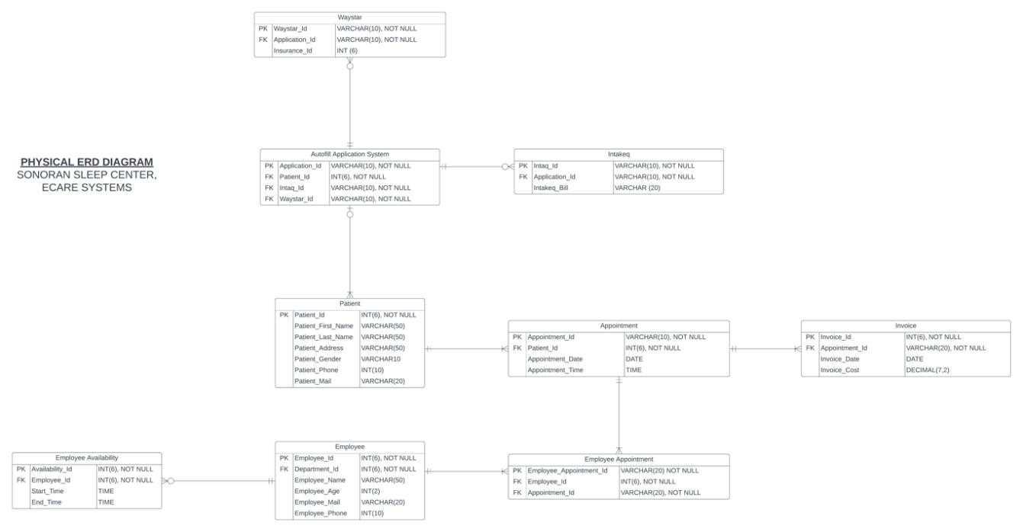

**Description-** There are a total of 9 entities in the physical ER diagram namely Patient, Appointment, Invoice, Employee, Employee Appointment, Employee Availability, Autofill Application System, Intakeq and Waystar. The relationship between all entities is indicated by the cardinality.

## 11.1 Entities

1. **Patient** (Primary Key = Patient_Id) Contains information regarding Patients including name, address, gender, phone and mail.
2. **Appointment** (Primary Key = Appointment_Id) Contains information regarding Appointments including date and time.
3. **Invoice** (Primary Key = Invoice_Id) Contains information regarding Invoice imcluding date and cost.
4. **Employee** (Primary Key = Employee_Id) Contains information regarding Employees including name, age, mail and phone.
5. **Employee Appointment** (Primary Key = Employee_Appointment_Id) Contains information regarding Employee Appointment.
6. **Employee Availability** (Primary Key = Availability_Id) Contains information regarding Employee Availability including start time and end time.
7. **Autofill Application System** (Primary Key = Application_Id) A tool which contains all information regarding Applications.
8. **Waystar** (Primary Key = Waystar_Id) Contains information of Waystar applications including insurance information.
9. **Intakeq** (Primary Key = Intakeq_Id) Contains information of Intakeq applications including Intakeq billing information.

## 12.0 Structure Chart

**Description:** The diagram of the structure chart demonstrates how patients engage with the API autofill application system, which leads to a decrease in data duplication from Waystar and IntakeQ after the eligibility check of patients' health insurance by the Waystar software. The Autofill Application system aids in copying the necessary data to IntakeQ as needed. Post that intakeQ sends the final invoices to billing system for final payment processing. Various entities, such as patients, the Employee Team, Waystar software, IntakeQ, Billing system, and the Autofill Application System, are involved in this process.

## 13.0 Architecture

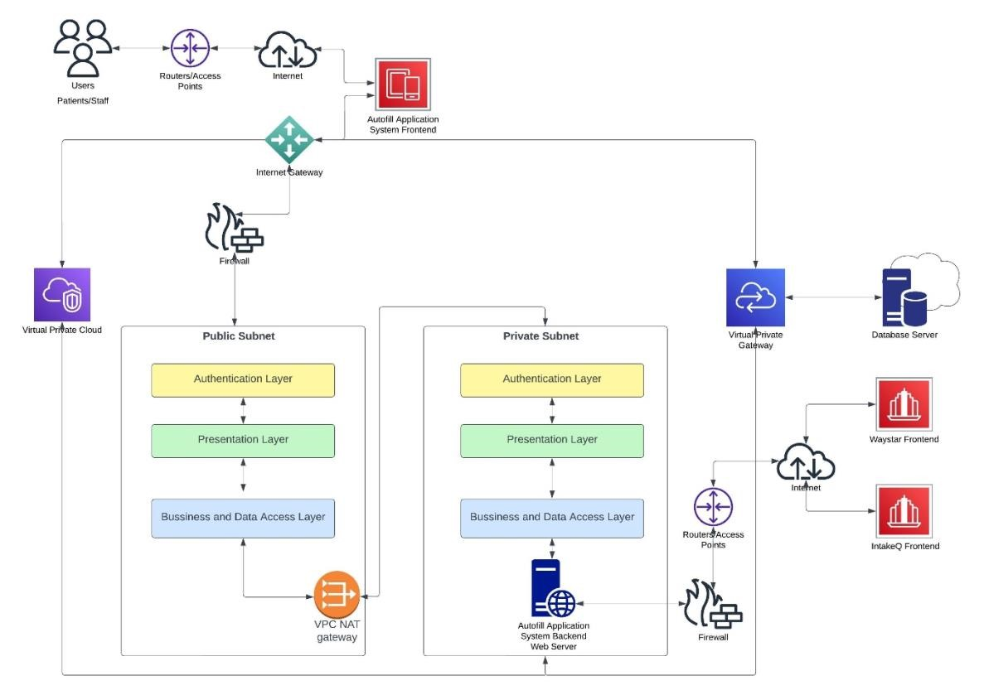

**Design Description:**

1. Users in our scenario which are Patients and Staff can access the system through their desktop.
2. The desktop accesses Autofill tool frontend via Internet and the traffic flows into the system

i.e., our Virtual Private Cloud(VPC) via Internet Gateway.

1. A virtual private cloud (VPC) is a private cloud that is housed inside of a public cloud and is secure and separated. Customers of VPC can perform all of the functions of a typical private cloud, including running code, storing data, hosting websites, and so on, but the private cloud

is hosted remotely by a public cloud provider. VPCs combine the data isolation of private cloud computing with the scalability and practicality of public cloud computing.

1. The VPC comprises of two subnets
   1. Public Subnet : A subnet (area or part of network) which would be accessible to patients.
   2. Private Subnet: A subnet which would be accessible to staff only since it comprises the Backend server which would handle the main workload for Autofill tool which would be to communication with 3rd Party services like Waystar and IntakeQ.
2. We have added an additional layer of protection by placing firewall before the traffic even enters the public subnet to weed out malicious traffic.
3. The data flows between public and private subnet via VPC NAT Gateway. NAT gateway is used so that instances in a private subnet can connect to services outside VPC, but external services cannot initiate a connection with those instances. This setup helps us to keep a publicfacing application, whereas the backend servers aren’t publicly accessible.
4. Security and routing will be set up so that the web servers can communicate with the Database servers.
5. Each subnet consists of 3 layers which are as follows:
   1. Authentication Layer: To authorize appropriate users to pass the traffic to layers below it.
   2. Presentation Layer: Ensures that communications that pass through it are in the appropriate form for the recipient application.
   3. Business and Data Access Layer: This layer is used for managing the data storage and retrieval of application. It is integrated with business-logic layer and the data storage system to provide an abstraction layer that allows the business-logic layer to interact with the data storage system without being aware of its specific implementation. The businesslogic layer is a crucial component of a software application that handles the processing of data and implementation of business rules.
6. The subnets interact with the database with the Virtual private gateway.
7. Third party services of Waystar and IntakeQ will be accessed by the Autofill tool backend server via Internet.
8. The VPC is hosted on AWS and the data will be stored at the corporate data centers owned by

AWS

1. Current capacity doesn’t demand more than one data center; however, the architecture can be scaled up if necessary.

## 14.0 User Interface

### 14.1 Sign Up Page

Users at Sonoran Sleep Center can sign up to the e-Care Autofill Application System by filling up details like the Organization Name, Username, Email, Password and if they are already a registered member, they can directly login to the application.

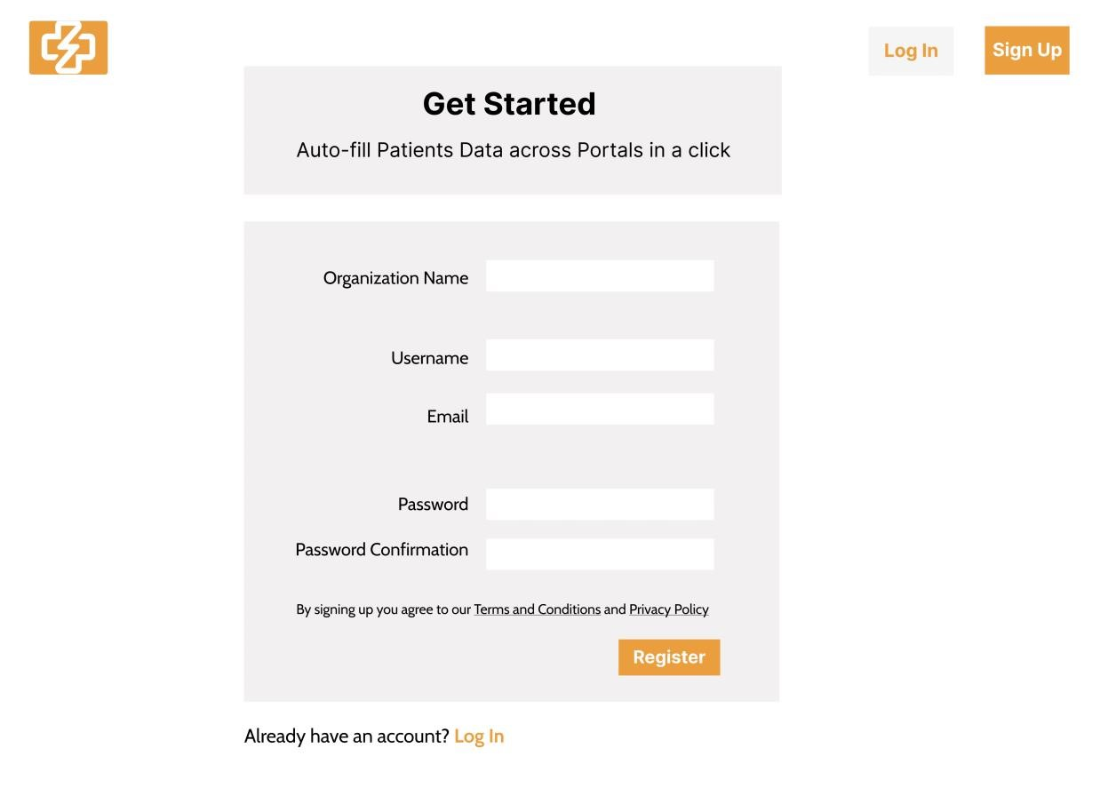

### 14.2 Login Page

This is the Login page, and here the user can enter their login credentials and can login, and if they have forgotten their password they can click on “Forgot Password” too, else, if they are not registered altogether then they can click on “Register” or on “Sign Up” option.

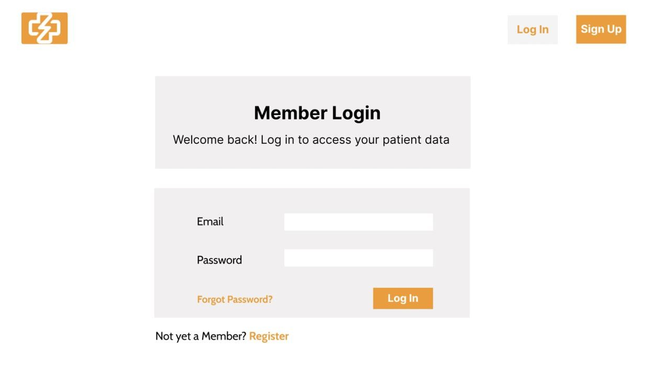

### 14.3 Dashboard

After the user signs in, then by default the dashboard page opens up where it can see various KPI’s like the total number of patient information that was captured by the application, the count of applications that were auto-filled by the application and finally the total time that the application saved else which would have been filled by humans manually by tallying data from one portal and putting the same to other portal.

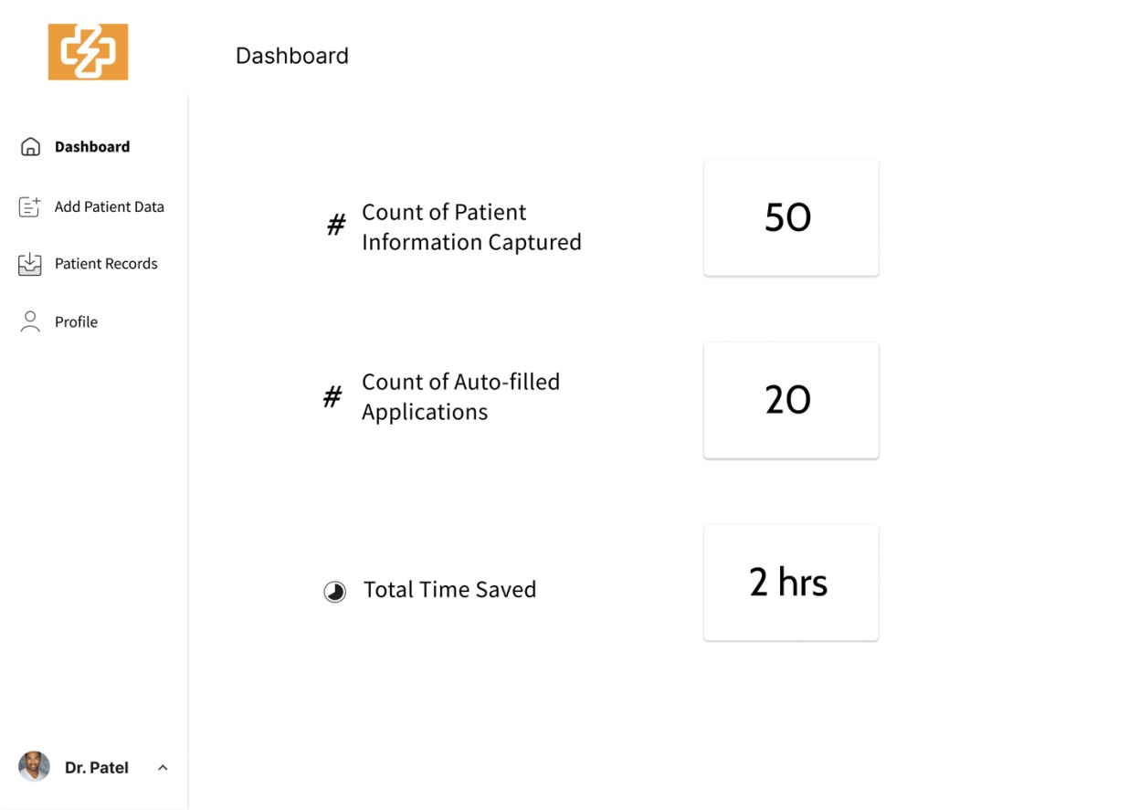

### 14.4 Add Patient Details

Next we have the Add Patient Data Page, usually our application captures the information automatically from one portal, and copies it to another portal, but if any of our staff wanted to add any of the patient information manually, so that they can re-use it later for auto-filling so this is why we had added the Add Patient Details page. It’s a two page form, where the first page is capturing patient details and appointment information, whereas the second page is capturing details like insurance and billing details.

#### 14.4.1 Add Patient Data – Page 1

Here, the user can fill various information related to patient like name, birth date, gender, email, phone, address, state and city; and can fill Appointment information like the date, time, doctor, and add any notes. For the fields which needed a date picker or time picker, we added it, and the fields which was a dropdown we added that too, and then once we have filled the Page-1 we just have to click “Next” to move to the next page, and the form doesn’t submits here. The fields which are mandatory are marked with asterisk “*”.

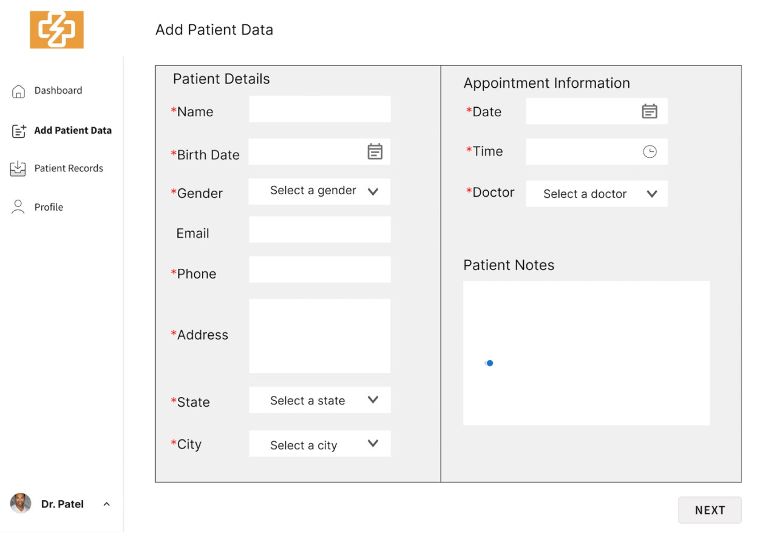

#### 14.4.2 Add Patient Data – Page 2

This is the page where we can finally submit our entire new patient data, including the ones that we had filled in the last page. Here, the user has to fill information related to insurance like insurer, policy no, insured name, insured date of birth and notes (if), and finally billing details with information like total value, net due, payment mode, card no, card holder name, card expiry and billing address. In this page too, the fields which had to be a dropdown or was a date field and we needed a date picker, all of this was added too. Finally, once the form is filled, the user can click on submit. The fields which are mandatory are marked with asterisk “*”.

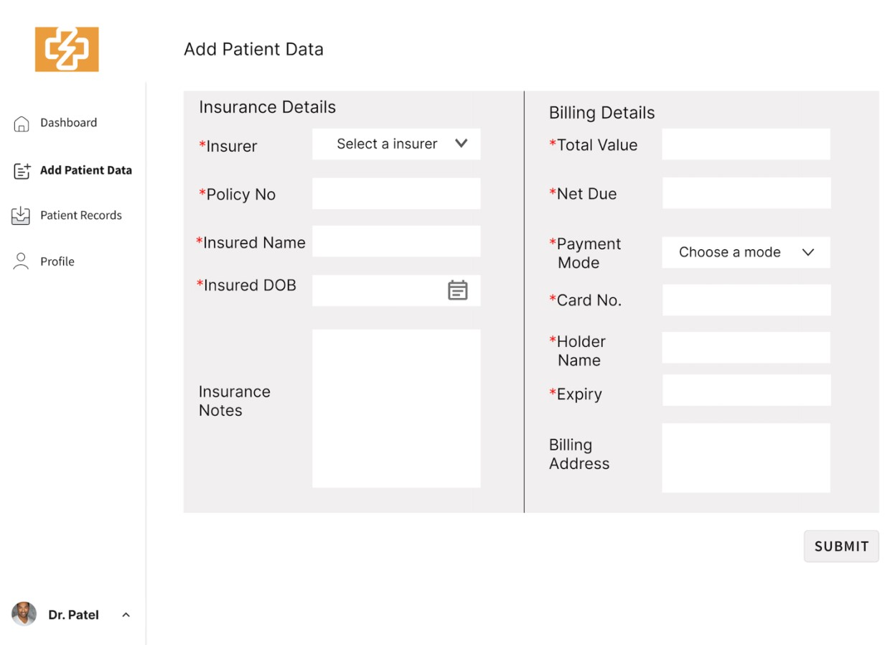

### 14.5 Patient Records

This is the page where all the patient information that was auto-captured by the application or which was added manually will be shown. Primarily, information like the Record ID, Insurance Approval, Patient Name, Doctor, Insurer and Bill Value is shown. Insurance Approval is basically the status of the insurance request, as we would just allow Approved requests to the IntakeQ portal. Further, we do have different filters too for the given page like filters by doctor name, or the insurer, or the record id. Also, this page is paginated, so we would usually show 10 entries per page, and then on next page. Each of the records on this page, if any of them is clicked, then the “Patient Summary” page opens up which has information about the Patient Record that was saved.

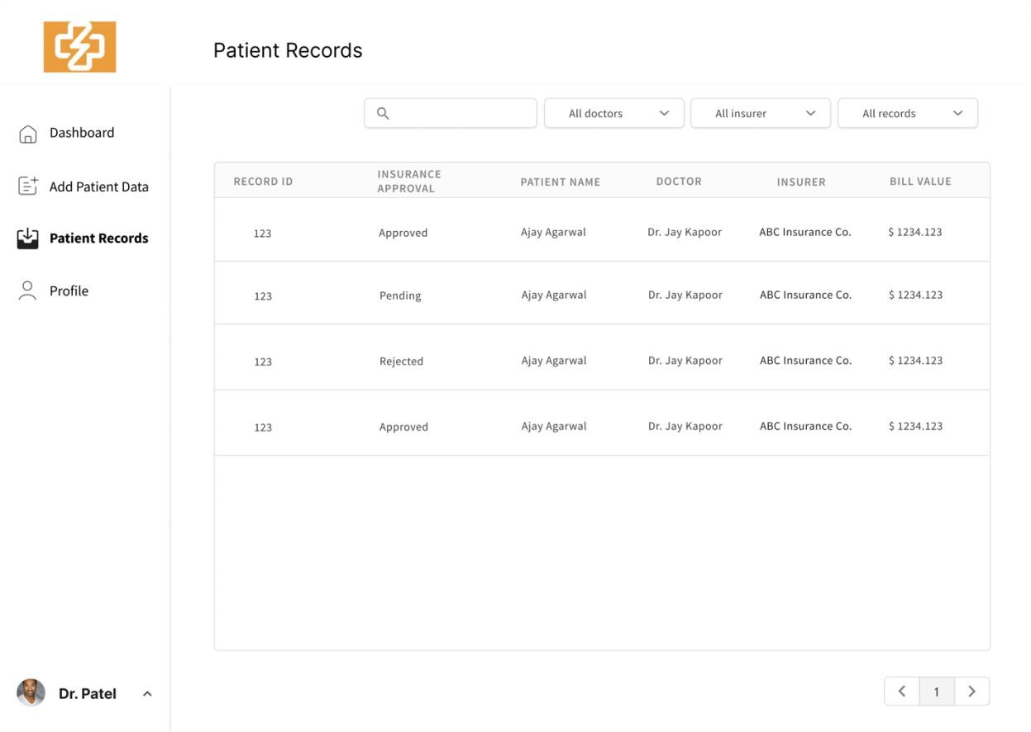

### 14.6 Patient Summary

Patient Summary basically shows the saved patient record, it has information on the Patient Details, Appointment Information, Insurance Details and Billing Details. The utility of this page was that the user can see the information for any patient record that was saved, and then further it can click on “Edit” and can enable the editing feature with which it can edit any information on the page.

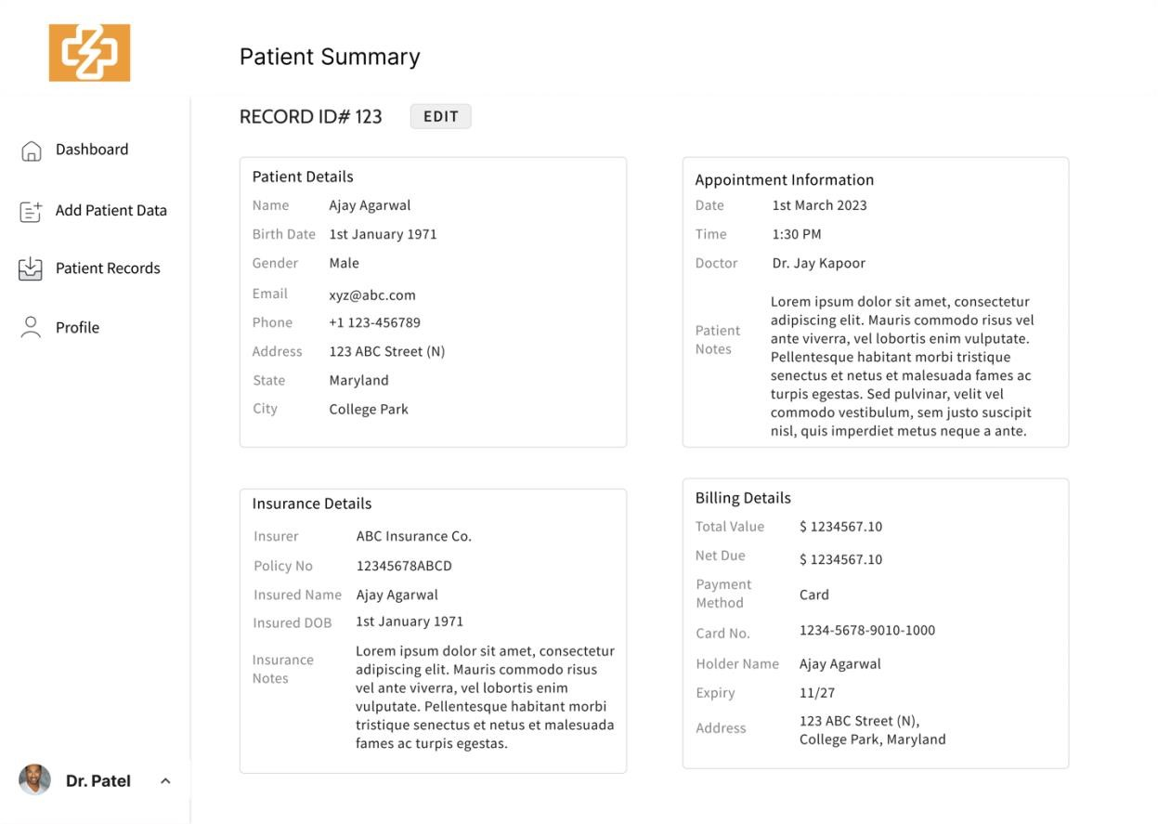

### 14.7 Edit Patient Data

This is the Edit Patient Data page, and here the user can edit any of the filled information, and can save it. So, we allow the Patient Details, Insurance Details, Appointment Information and Billing Details to be editable.

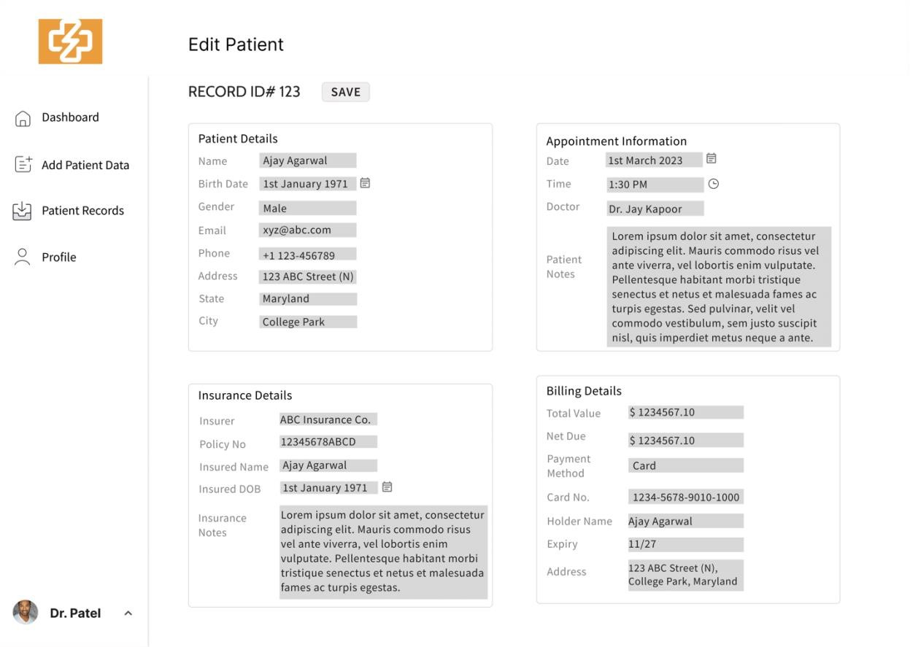

### 14.8 Profile

This is the User profile section, here the user can see their profile like their name, birth date, gender, email, phone, address, state, city and organization, and there is also an option to edit that information.

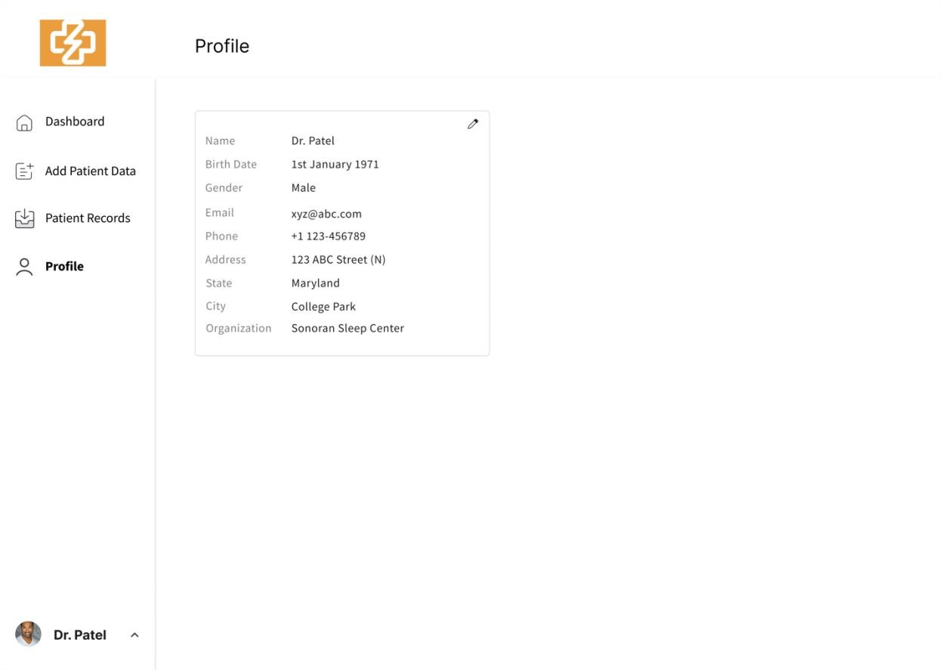

### 14.9 InTakeQ <> e-Care Interaction Journey

On any given portal be it InTakeQ or WayStar, our Application will activate when it is on any of the application, and as it is shown how it will display when it is activated, and if it has to “capture” any of the details that are being filled it will capture them or else if it has to fill the data into the fields then the user has the option to select the patient from the dropdown (as shown), and then once it chooses it then the application fills all the fields, thereby saving the chances of human errors and saving time, and improving efficiency. In case of IntakeQ, only those patient records will be shown in the dropdown which had the “Insuranc Approval” status as “Approved” else it won’t be shown if its “Pending” or “Rejected.

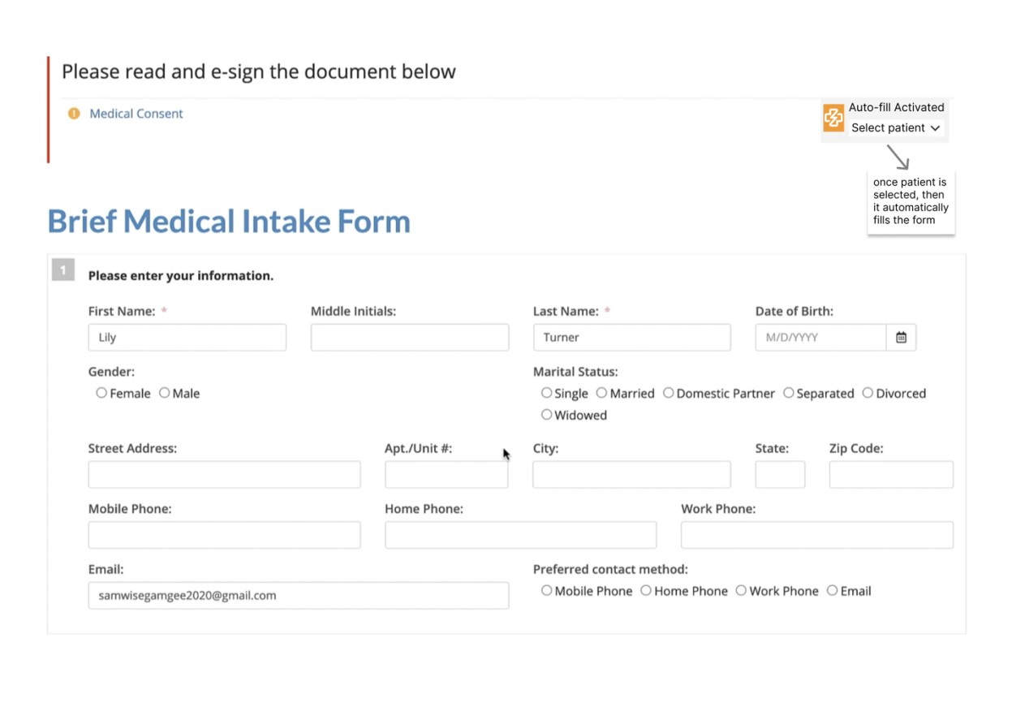

### 14.10 WayStar <> e-Care Interaction Journey

On any given portal be it InTakeQ or WayStar, our Application will activate when it is on any of the application, and as it is shown how it will display when it is activated, and if it has to “capture” any of the details that are being filled it will capture them or else if it has to fill the data into the fields then the user has the option to select the patient from the dropdown (as shown), and then once it chooses it then the application fills all the fields, thereby saving the chances of human errors and saving time, and improving efficiency.

**1**

**5**

**.0**

**Testing Plan**

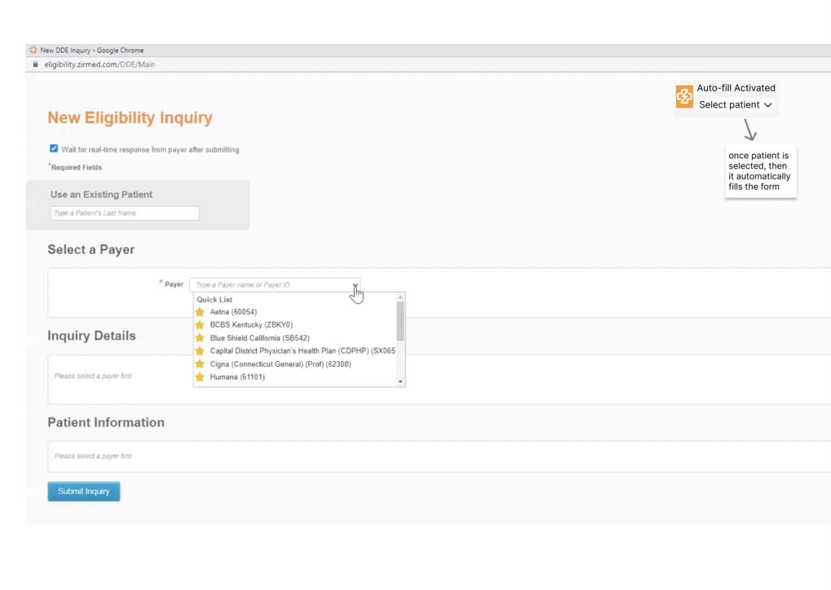

### 15.1 Unit Testing

We will test each function or process's individual components during unit testing to make sure everything is operating as it should and that there are no problems. The objective is to test each individual unit or component of the site separately to find any early testing bugs in the code. Unit testing is a crucial stage in the development process because, when done properly, it can aid in finding early code issues that could be more challenging to identify in subsequent testing phases.

|  |  |  |  |  |
| --- | --- | --- | --- | --- |
| **Test**  **Case**  **#** | **Test Case** **Name** | **Test Case** **Description** | **Inputs** | **Expected Output** |
| 1. | Account Creation | Checking the creation of user/staff accounts | Valid user email id, valid username valid user Password | User account must be successfully created |
| 2. | Account Login | Checking login of existing user/staff accounts | Valid existing user email id,  valid, valid username  existing user password | User must be able  to log into their account successfully |
| 3. | Upload New  Patient  Information | Checking if the user can add new patient information successfully | Patient Information and Insurance  Details | Patient listed and  visible on Patient  Records |
| 4. | Autofill of  Patient  Information | Checking if the  Patient  Information gets auto filled onto  Waystar based on autofill selection | Patient Name | Approval of patient record and approval status reflected on dashboard. |
| 5. | Patient  Records  Filter | Checking if the The patient record reflects information based on the filter applied | Filter selection from the search box and dropdowns | The dashboard must successfully reflect information based on the filter applied and search box text |

### 15.2 Stress Testing

To determine whether software or hardware is performing satisfactorily and to eliminate testingrelated faults, stress testing is employed. Here, we've run stress tests on a variety of test cases to see if they encounter any issues as a result of process loading, underlocking, or overlocking.

Error handling frequently involves stress testing. Any issues will be resolved during testing to ensure that users have a positive patient portal system experience.

|  |  |  |  |
| --- | --- | --- | --- |
| **Test**  **Case**  **#** | **Test Case Name** | **Test Case Description** | **Identify** |
| 1. | Create  New Patient  Records | Checking if the user can upload patient records successfully | Maximum number of patient records that can be added.  Maximum number of patient records that can be added once. |
| 2. | Dashboard  Filter | Checking if the dashboard reflects. information based on the filter applied | Maximum number of  filters that system allows.  Maximum number of filters that a user can make.  Maximum number of filters that can be created at once. |
| 4. | Account Login | Checking login of existing user accounts | Maximum number of logins that can be made per account.  Maximum number of logins that can be made at once. |
| 5. | Patient Record  Status  Updation | Checking if a patient's insurance is valid on Waystar and updating automatically on Patient  Records | The velocity at which the status is updated as soon as Waystar approves patient information |

### 15.3 Integration Testing

For the following processes, we will evaluate the experience of the integrations associated with this new information system to ensure that each integration is working successfully and that there are no issues present. The goal is to test each interface separately and test the navigation between all interfaces to ensure that all social media accounts and the payment portal connect successfully with the main patient portal. Any common errors will need to be fixed in an update so that the users can have a successful experience with the integrations offered by this patient portal system.

|  |  |  |  |  |
| --- | --- | --- | --- | --- |
| **Test**  **Case #** | **Test Case Name** | **Test Case Description** | **Inputs** | **Expected Output** |
| 1. | Patient  Records and  Waystar  Integration | Checking if the status on Waystar is reflected in the patient records. | Check Insurance  Information on Waystar | Insurance validity should reflect  accordingly within the patient records |
| 2. | Edit Patient  Record  Button | Checking if the edit button on a patient  record redirects to enter new information | Click on a patient record within the  Patient records portal | Should redirect the user to edit patient data and save the data accordingly. |
| 3. | Patient  Records and  IntakeQ  Integration | Checking if the approved patients on the records are  populated in IntakeQ. | Input billing information on  IntakeQ | Appropriate patient information should be filled in automatically |
| 4. | Dashboard numbers | Checking if  The count of users is right on the dashboard. | Clicking on the  Dashboard button | Appropriate count based on patient  records should be present. |
| 5. | Payment Details | Checking if payment  information is  stored following necessary protocols | Check card details | Billing details are to be stored in an encrypted database. |

### 15.4 Systems Testing

Instead of testing individual functionalities like previously, we want to make sure that the entire system works as intended during systems testing. We want to make sure that using one functionality successfully will enable the user to utilize the next. Before releasing the system, the development team performs this testing in preparation for end users' acceptance testing. To make sure that functionalities function well with one another, these tests must be performed on the patient's side as well as the administrative/support staff and medical staff's sides.

|  |  |  |  |  |
| --- | --- | --- | --- | --- |
| **Test**  **Case**  **#** | **Test Case** **Name** | **Test Case Description** | **Prerequisite** **Function** | **Expected Output** |
| 1. | Autopopulate  Patient  Data | Verify that the  Billing Information Autofill tool can successfully autopopulate patient data into Waystar and IntakeQ forms. | The Billing  Information  Autofill tool is integrated with both Waystar and IntakeQ. | All patient data, such as name, date of birth, address, and insurance information, is correctly filled in the appropriate form fields. |
| 2. | Manual  Data Entry  Override | Verify that staff can manually enter or override data in Waystar and IntakeQ  form fields if necessary. | The Billing  Information Autofill tool is integrated with both Waystar and IntakeQ, and staff has been granted the option to manually enter or override data. | The Billing  Information Autofill tool allows staff to enter or override data without causing errors or unexpected behavior. |
| 3. | Data  Validation | Verify that the  Billing Information Autofill tool can validate data entered in Waystar and IntakeQ forms. | The Billing  Information  Autofill tool is integrated with both Waystar and IntakeQ, and staff has entered data into the appropriate form fields. | The Billing  Information Autofill tool validates data entries, ensuring that data entered meets the appropriate criteria. |
| 4. | Data  Suggestions | Verify that the  Billing  Information Autofill tool suggests possible  field entries on  Waystar and IntakeQ software with a couple of letters of the patient’s name typed in. | Few letetrs of patient name typed | The Billing  Information Autofill tool provides accurate suggestions and predictions for data entry, speeding up the process for staff. |
| 5. | Data  Security | Verify that the Billing Information Autofill tool is secure and protects sensitive patient data from unauthorized access. | The Billing  Information  Autofill tool is integrated with both Waystar and IntakeQ, and staff has entered patient data into the appropriate form fields. | The Billing  Information Autofill tool protects patient data from unauthorized access and ensures that sensitive information remains secure. |

### 15.5 Acceptance Testing

In order to guarantee that the user interface satisfies their needs for usability and performance, we will assess the experience of a randomly selected fraction of users for the subsequent stages.

|  |  |  |  |
| --- | --- | --- | --- |
| **Test**  **Case**  **#** | **Test Case Name** | **Test Case Description** | **Required User Sign-Off** |
| 1. | Auto-populate Patient Data | Ensure that the Billing Information Autofill tool can successfully autopopulate patient data into Waystar and IntakeQ forms as per the business requirements and user requirements. | Admin/Support  Team Medical  Staff and Doctors |
| 2. | Manual Data  Entry  Override | Verify that the Billing Information Autofill tool allows staff to manually enter or override data in Waystar and IntakeQ fields if necessary, as per the user requirements. | Admin/Support  Team Medical  Staff and Doctors |
| 3. | Editing Patient Record | Staff must be able to edit Patient Records at any time once created. | Admin/Support  Team Medical  Staff and Doctors |
| 4. | Data Validation | Verify that the Billing Information Autofill tool can validate data entered in Waystar and IntakeQ forms, ensuring accuracy and completeness, as per the functional and nonfunctional requirements. | Admin/Support  Team Medical  Staff and Doctors |
| 5. | Data  Suggestions | Verify that the Billing Information Autofill tool suggests possible field entries on Waystar and IntakeQ software with a couple of letters of the patient’s name typed in, as per the user requirements. | Admin/Support Team Medical Staff and Doctors |

## 16.0 Implementation Plan

### 16.1 Objectives

Primary: Sonoran Autofill Tool is successfully completed and deployed.

Supporting Objectives: Training end users, Preparation for maintenance and operations.

### 16.2 Details and Deliverables

|  |  |  |  |
| --- | --- | --- | --- |
| **Tasks** | **Deliverables** | **Developed By** | **Approved By** |
| **User Interface** includes an interface for | Deliver interfaces that meet the business need and all.  requirements including | Development Team | System  Analyst /  Project  Manager |

|  |  |  |  |
| --- | --- | --- | --- |
| Doctors, Staff, and Admin Support based upon usability. | * Account Creation ● Account Login ● Create Patient   Records   * Edit Patient Records ● Autofill Patient Information * Status Updation |  | Project Sponsor |
| **Integration** includes data and functionality | Integration with  IntakeQ and Waystar | Development Team | System  Analyst /  Project  Manager  Project  Sponsor |
| **Developer/User Documentation**  includes all technical documentation delivered during the project; all.  documentation necessary to effectively operate and maintain the system. based on user types. | ● System  Documentation: Pro vide users with infrastructure setup, daily process information that includes performance. assessment ● Online  documentation: incl udes simulations and knowledge base articles. | Development Team | System  Analyst /  Project  Manager  Project  Sponsor |
| **License Structure** | ● Identifies specific ways the software can and cannot be used by Sonoran Sleep Center. ● Ensures teams for  Sonoran Sleeping Centre’s access/support. | System  Analyst/  Project  Manager | Project Sponsor |

|  |  |  |  |
| --- | --- | --- | --- |
| **Post-Implementation Review Report** summarizes the assessment of Implementation.  activities at the end of the Implementation  Phase | ● Summarize assessment of  implementation activities ● Evaluate the effectiveness of the system development after the system has been in production ● Determine if the system does what it was designed to do | System  Analyst/  Project  Manager | Project Sponsor |
| **Standard Operating Procedures (SOP)** defines in detail how the Systems Team will perform the business processes related to the operations and maintenance of the system. Whereas the User Guide is focused on the use of the system specifically, the SOP addresses all related business processes. | Provide detailed instructions for future business processes.    Ensure consistent execution of business processes.    Drive performance improvement and improve  organizational results | Development Team | System  Analyst /  Project  Manager  Project  Sponsor |
| **Training Plan** includes a full schedule of end-user training for  Students/Alumni, Employers, and Faculty. | Schedule and notify plan to end-users to ensure all system participants can operate systems based on business rules. ● Doctor Training Plan   * Staff Training Plan * Admin Support   Training Plan | System  Analyst/  Project  Manager | Project Sponsor |
| **Infrastructure**  Overall system Performance as intended based on business needs | * Load   Requirements Assessment: Ensure system can function with full user load.   * Infrastructure   Setup-Up  Assessment: Ensures process application functionality | Development Team | System  Analyst /  Project  Manager  Project  Sponsor |
| **Rollout Plan**  Schedule and methods for actual deployment of CP for users. | * Deployment Schedule * Development Response ● Plan: ensure optimal IT support response for the initial rollout. | Project Manager | Project Sponsor |

### 16.3 Implementation Plan Schedule

|  |  |  |  |
| --- | --- | --- | --- |
| **Task Name** | **Owner** |  | **Date** |
| **Development Activities** |  |  |  |
| Database | Development team | 3/14/23 |  |
| UI | Development team | 4/4/23 |  |
| Integrations | Development team | 4/30/23 |  |
| Medical Reports | System Analyst | 4/30/23 |  |
| **Testing Activities** |  |  |  |

|  |  |  |
| --- | --- | --- |
| Testing Planning | System Analyst/Project Manager | 5/2/23 |
| Unit Testing | Development team | 5/6/23 |
| Integration Testing | Development team | 5/7/23 |
| Stress Testing | Development team | 5/8/23 |
| System Testing | Development team | 5/10/22 |
| Acceptance Testing | Development team / Endusers | 5/11/22 |
| **Documentation Prep** |  |  |
| Developer Documentation | Development team | 5/9/23 |
| User documentation | Development team | 5/9/23 |
| **Training** |  |  |
| Training Planning | System Analyst | 5/11/23 |
| User training development | System Analyst | 5/12/23 |
| User training review | System Analyst | 5/13/23 |
| User training rollout | System Analyst | 5/14/23 |
| **Rollout** |  |  |
| System Architecture planning | Development team | 5/16/23 |
| Infrastructure Prep | Development team | 5/17/23 |
| License structure | System Analyst/Project Manager | 5/18/23 |
| Deployment | Development team | 5/19/23 |
| Data Migration steps | Development team | 5/20/23 |
| User set up | Development team | 5/21/23 |
| User training | Development team | 5/22/23 |
| Pilot Rollout Plan/Phase Rollout plan | System Analyst/Project Manager | 5/23/23 |
| Rollback steps | Development team | 5/24/23 |
| Day 0 Deployment | Development team | 5/25/23 |
| Support set up | Development team | 5/26/23 |
| Week 1 support plan | System Analyst/Project Manager | 5/30/23 |
| Week 1 daily review meeting Development team |  | 6/6/23 |
| Post rollout | System Analyst/Project Manager 6/10/22 |  |

## 17. Conclusion

In order to establish a comprehensive information system that securely stores critical data across multiple software of e-Care Systems and prevents data duplication, specific requirements were identified. The purpose of introducing the Autofill Application System was to avoid duplicating data and minimize errors caused by manual input. The project goals and scope were clearly defined before proceeding to the system analysis and design phases. The main goal was to develop a strong information system for e-Care Systems that improves the efficiency and productivity of daily office operations, which ultimately results in the success and expansion of the organization.